UNIT - V
CODE OPTIMIZATION AND RUN TIME ENVIRONMENTS
5.1 Introduction
- To create an efficient target language program.
- The types of code-improving transformations that a programmer can be expected to use to improve the performance of a program.
- The representation of programs on which transformation will be applied.
Criteria for code-improving transformation
- The best program transformations are those that yield the most benefit for the least effort.
- The transformations provided by an optimizing compiler should have several properties.
1. The transformation must preserve the meaning of programs.
2. A transformation must speed up programs by a measurable amount.
3. A transformation must be worth the effort.
Getting better performance
- Dramatic improvements in the running time of a program (such as cutting the running time from a few hours to a few seconds) are usually obtained by improving the program at all levels, from the source level to the target level.
- At each level, the available options fall between the two extremes of finding a better algorithm and of implementing a given algorithm so that fewer operations are performed.

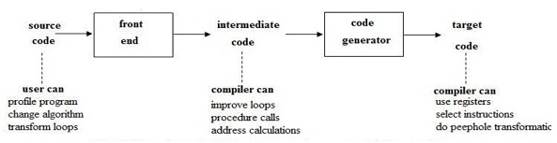

An organisation for an optimizing compiler
- There are several levels at which a program can be improved.
- Since the techniques needed to analyze and transform a program that do not change significantly with the level, the transformation of intermediate code is done using the organisation.
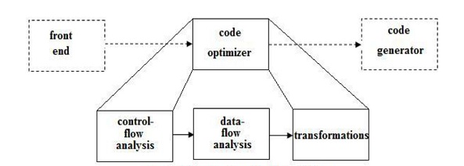

- The code improvement phase consists of control-flow and data-flow analysis followed by the application of transformations.
- The code generator produces the target program from the transformed intermediate code.
- The organisation has the following advantages:
- The operations needed to implement high-level constructs are made explicit in the intermediate code, so it is possible to optimize them. Recomputation of expressions can be eliminated.
- The intermediate code can be independent of the target machine, so the optimizer does not have to change much if the code generator is replaced by one of the different machine.

5.2 The Principal Sources of Optimization

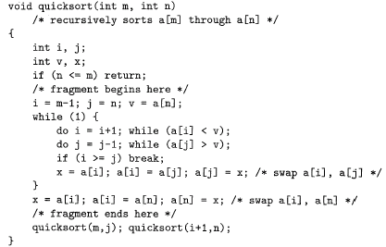
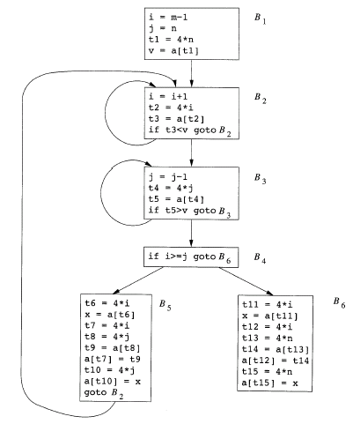

- A transformation of a program is called local if it can be performed by looking only at the statements in a basic block; otherwise, it is called global.
- Many transformations can be performed at both the local and global levels.
- Local transformations are usually performed first.
Function preserving transformation
- There are number of ways in which a compiler can improve a program without changing the function it computes.
- Common subexpression elimination, copy propagation, dead-code elimination, and constant folding are common examples of such function-preserving transformations.

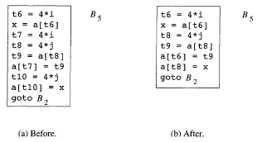
Common Subexpressions
- An occurrence of an expression E is called a common subexpression if E was previously computed, and the values of variables in E have not changed since the previous computation.
- The Recomputation of the expression can be avoided if the previously computed value was used.
- For example, the assignments to t7 and t10 have the common subexpressions 4*I and 4*j, respectively, on the right side in Fig 5.6(a).
- They have been eliminated in Fig 5.6(b), by using t6 instead of t7 and t8 instead of t10.
- Eliminate the common subexpression both global and local from Fig 5.5

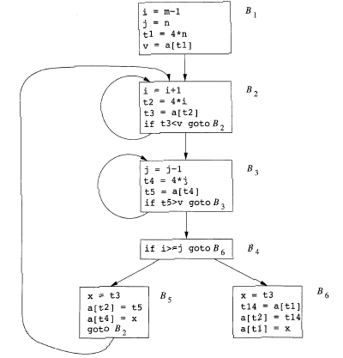
After common sub expression elimination

Copy Propagation
- From above fig. Block B5 can be further improved by eliminating x using two new transformations.
- One concerns assignments of the form f := g called copy statements or copies.
- The idea behind the copy propagation transformation is to use g for f, whenever possible after the copy statement f := g.
- For example, the assignment x := t3 in block B5 of Fig 5.7 is a copy.
- Copy propagation applied to B5 yields:
x := t3
a[t2] := t5
a[t4] := t3
goto B2 (5.1)
- This copy propagation eliminates the assignment to x.

Dead-Code Elimination
- A variable is live at a point in a program if its value can be used subsequently; otherwise, it is dead at that point.
- For example, the statement
if (debug) print . . .
. . .
debug = false;
- By data flow analysis, it may be possible to deduce that each time the program reaches this statement, the value of debug is false.
- Here, the print statement is dead, because it cannot reach print statement when debug = false.
- Deducing at compile time that the value of an expression is a constant and using the constant instead is known as constant folding.
- One advantage of copy propagation is that it often turns the copy statement into dead code.
- For example, copy propagation followed by dead-code elimination removes the assignment to x and transforms into:
a[t2] := t5
a[t4] := t3
goto B2
this code is further improvement of block B5.
Loop Optimizations
- The running time of a program may be improved if the number of instructions in an inner loop is decreased, even if the amount of code outside that loop is increased.
- Three techniques are important for loop optimization: code motion, which moves code outside a loop, induction-variable elimination, which applies to eliminate i and j from the inner loops B2 and B3 of Fig 5.7, and, reduction in strength, which replaces an expensive operation by a cheaper one, such as multiplication by an addition.
Code Motion
- An important modification that decreases the amount of code in a loop is code motion.
- This transformation takes an expression that yields the same result independent of the number of times a loop is executed (a loop-invariant computation) and places the expression before the loop.
- For example, evaluation of limit-2 is a loop-invariant computation in the following while-statement:
while ( i <= limit-2 ) /* statement does not change limit */
Code motion will result in the equivalent of
t = limit-2;
while ( i <= t ) /* statement does not change limit or t */
Induction Variables and Reduction in Strength
- Loops are usually processed inside out.
- For example, consider the loop around B3.

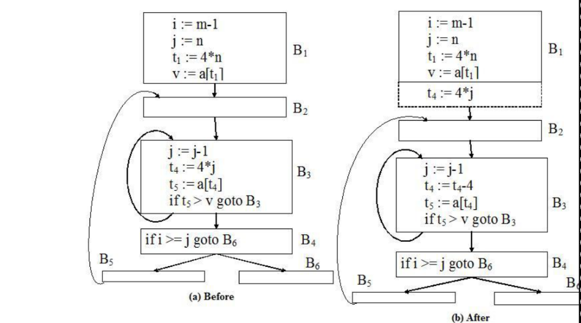
Strength reduction applied 4*j in Block B3

- The values of j and t4 remain in lock step; every time the value of j decreases by 1, that of t4 decreases by 4 because 4*j is assigned to t4. Such identifiers are called induction variables.
- After reduction in strength is applied to the inner loops around B2 and B3, the only use of i and j is to determine the outcome of the test in block B4.
- The values of i and t2 satisfy the relationship t2 = 4*I, while those of j and t4 satisfy the relationship t4 = 4*j, so the test t2 >= t4 is equivalent to i >= j.
- Once this replacement is made, i in block B2 and j in block B3 become dead variables and the assignments to them in these blocks become dead code that can be eliminated, resulting in the flow graph shown in Fig 5.9

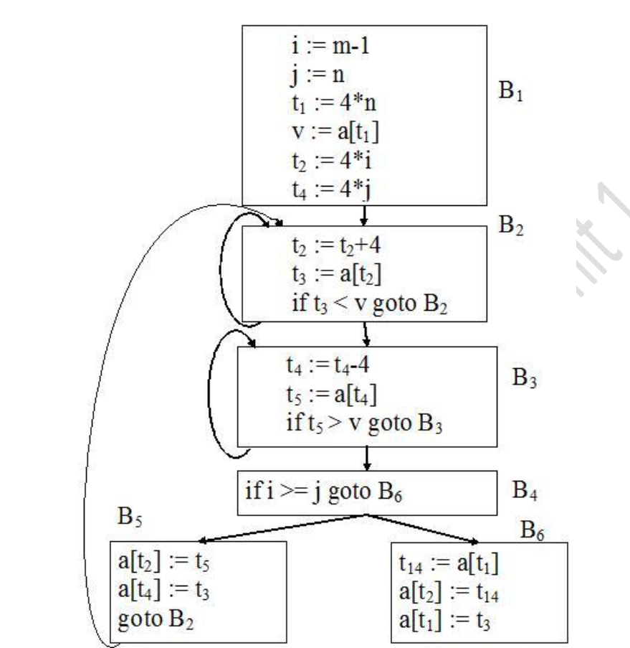
Flow graph after induction-variable elimination

- The code-improving transformations have been effective.
- In the above fig, the number of instructions in blocks B2 and B3 has been reduced from 4 to 3 from the original flow graph in Fig 5.5, in B5 it has been reduced from 9 to 3, and in B6 from 8 to 3.
- Block B1 has grown from four instructions to six, but B1 is executed only once in the fragment, so the total running time is hardly affected by the size of B1.

5.3 Optimization of Basic Blocks
- The structure-preserving transformations, such as common subexpression elimination and dead-code elimination, and algebraic transformations such as reduction in strength can be implemented by constructing a dag for a basic block.
- Consider that there is a node in the dag for each of the initial values of the variables appearing in the basic block and there is a node n associated with each statement s within the block. The children of n are those nodes corresponding to statements that are the last definitions prior to s of the operands used by s. Node n is labeled by the operator applied at s, and also attached to n is the list of variables for which it is the last definition within the block. The nodes whose values are live on exit from the block; these are the output nodes.
- Common subexpressions can be detected by observing whether there is an existing node n with the same children, in the same order, and with the same operator. If so, n computes the same value as m (a new node m is about to be added) and may be used in its place.
- The operation on dags that corresponds to dead-code elimination is quite straightforward to implement. Delete from a dag any root (node with no ancestor) that has no live variables. Repeated application of this transformation will remove all nodes from the dag that correspond to dead-code.
- The use of algebraic identities. Algebraic identities represent another important class of optimizations on basic blocks.
- For example, the arithmetic identities, such as
x + 0 = 0 + x = x
x – 0 = x
x * 1 = 1 * x = x
x / 1 = x
- Another class of algebraic optimizations include reduction in strength, i.e. replacing a more expensive operator by a cheaper one as in
x ** 2 = x * x
2.0 * x = x + x
X / 2 = x * 0.5
- A third class of related optimizations is constant folding. Here the constant expression at compile time is evaluated and replace the constant expressions by their values. Thus the expression 2 * 3.14 would be replaced by 6.28
- The relation operators <=, >=, <, >, = and ≠ sometimes generate unexpected common subexpressions. For example, the condition x>y can also be tested by subtracting the arguments and performing a test on the condition code set by the subtraction. Thus, only one node of the dag need be generated for x-y and x>y.
- Associate laws may also be applied to expose common subexpressions. For example, if the source code has the assignments
a := b + c
e := c + d +b
the following intermediate code might be generated:
a := b + c
t := c + d
e := t + b
o If t is not needed outside this block, we can change this sequence to
a := b + c
e := a + d
using both the associativity and commutativity of +.

5.4. Introduction to Global Data-Flow Analysis
- In order to do code optimization and a good job of code generation, a compiler needs to collect information about the program as a whole and to distribute this information to each block in the flow graph.
- For example, Knowing what variables are live on exit from each block could improve register usage.
- How to use knowledge of global common subexpressions to eliminate redundant computations.
- How a compiler could take advantage of “reaching definitions,” such as knowing where a variable was last defined before reaching a given block, in order to perform transformations like constant folding and dead-code elimination.
- These are some examples for data-flow information that an optimizing compiler collects by a process known as data-flow analysis.
- Data-flow information can be collected by setting up and solving systems of equations that relate information at various points in a program.
- A typical equation has the form
Out[S] = gen[S] U (in[S] – kill[S])
And can be read as, “the information at the end of a statement is either generated within the statement, or enters at the beginning and is not killed as control flows through the statement.” Such equations are called data-flow equations.
- The details of how data-flow are set up and solved depend on three factors.
- The notions of generating and killing depend on the desired information, i.e. on the data-flow analysis problem is solved. For some problems, instead of proceeding along with the flow of control and defining out[S] in terms of in[S], we need proceed backwards and define in[S] in terms of out[S].
- Since data flows along control paths, data-flow analysis is affected by the control constructs in a program. When we write out[S] we implicitly assume that there is a unique end point where control leaves the statement.
- There are details that go along with such statements as procedure calls, assignments through pointer variables, and even assignments to array variables.
Points and Paths
- Within a basic block, the point between two adjacent statements, as well as the point before the first statement and after the last.

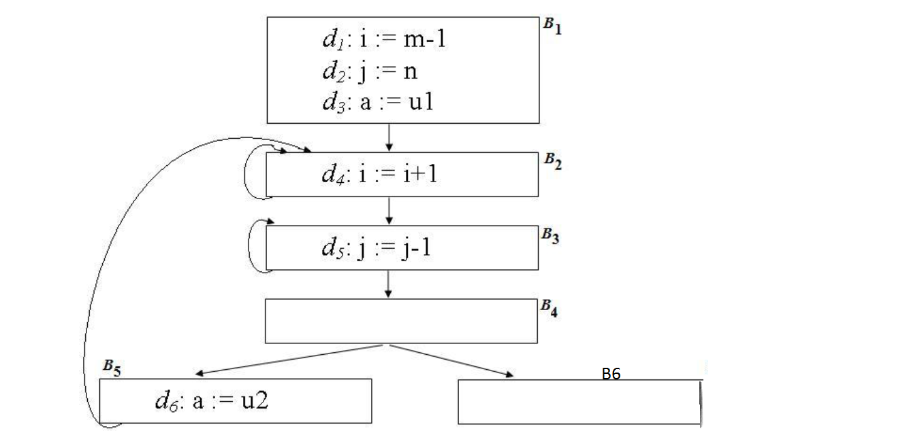
Flow graph

- Block B1 in above fig, has four points: one before any of the assignments and one after each of the three assignments.
- A path from p1 to pn is a sequence of points p1,p2, . . . ,pn such that for each i between 1 and n-1, either
- pi is the point immediately preceding a statement and pi+1 is the point immediately following that statement in the same block, or
- pi is the end of some block and pi+1 is the beginning of a successor block.
- For example, in Fig 5.10, there is a path from the beginning of block B5 to the beginning of block B6. It travels the end point of B5 and then through all the points in B2, B3, and B4 before it reaches the beginning of B6.
Reaching Definitions
- A definition of a variable x is a statement that assigns, or may assigns, a value to x.
- The most common forms of definition are assignments to x and statements that read a value from an I/O device and store it in x.
- These statements certainly define a value for x and they are referred to as unambiguous definitions of x.
- The other kind of statements that define value of x are called ambiguous definitions.
- The most usual forms of ambiguous definitions of x are:
- A call of a procedure with x as a parameter (other than a by-value parameter) or a procedure that can access x because x is in the scope of the procedure.
- An assignment through a pointer that could refer to x. for example, the assignment *q := y is a definition of x if it is possible that q points to x.
- A definition d reaches a point p if there is a path from the point immediately following d to p, such that d is not “killed” along that path.
Data-flow Analysis of Structured Program
- Flow graphs for control-flow constructs such as do-while statements have a useful property; there is a single beginning point at which control enters and a single end point that control leaves from when execution of the statement over.
- Exploit the property of the definitions reaching the beginning and end of statements with the following syntax
S -> id := E | S ; S | if E then S else S | do S while E
E -> id + id | id

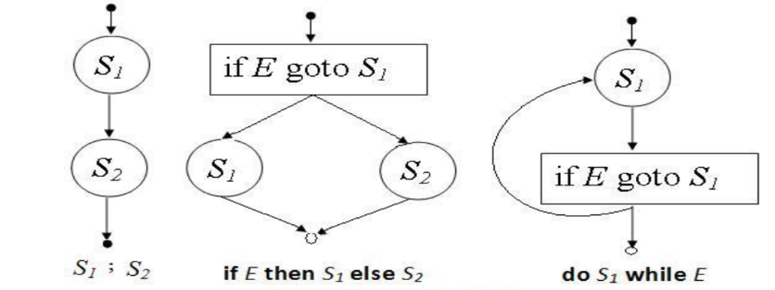
Some structured control constructs

A primary purpose of this section is to study the data-flow equations summarized in the above fig.

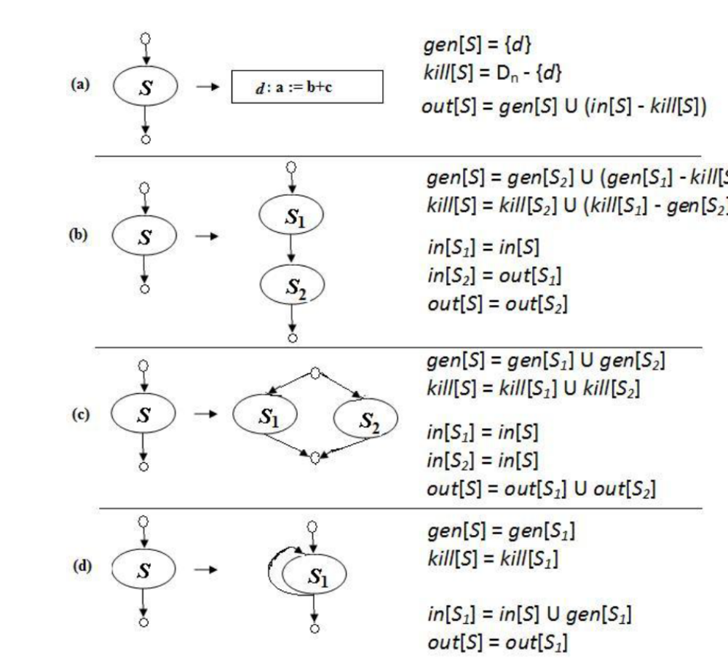
Data flow equations for reaching definitions

- Define a portion of a flow graph called a region to be a set of nodes N that includes a header, which dominates all other nodes in the region.
- All edges between nodes in N are in the region, except for some enter the header.
- The portion of a flow graph corresponding to a statement S is a region that obeys the further restriction that control can flow to just one outside block when it leaves the region.
- Sets in[S], out[S], gen[S], kill[S] for all statements S are inductive or syntax-directed.
- Sets gen[S], kill[S] are synthesized attributes; they are computed bottom-up, from the smallest statement to the largest.
Local Reaching Definitions
- Space for data-flow information can be traded for time, by saving information only at certain points and recomputing information at intervening points.
- Basic blocks are usually treated as a unit during global flow analysis, with attention restricted to only those points that are the beginnings of blocks.
- When needed, the reaching definitions for all points in a block can be calculated from the reaching definitions for the beginning of a block.
- Consider a sequence of assignments S1 ; S2 ; . . . ; Sn in a basic block B.
- Refer the beginning of B as point p0, to the point between statements Si and Si+1 as pi, and to the end of the block as point pn.
- The definitions reaching point pj can be obtained from in[B] by considering the statements S1 ; S2 ; . . . ; Sj, starting with S1 and applying the data-flow equations in Fig 5.12 for cascades of statements.
- Initially, let D = in[B].
- When Si is considered, delete from D the definitions killed by Si and add the definitions generated by Si.
- At the end, D consists of the definitions reaching pj.
Use-Definition Chains
- It is often convenient to store the reaching information as “use-definition chains” or “ud-chains”, which are lists of all definitions that reach that use
- If a use of a variable a in block B is preceded by no unambiguous definition of a, then the ud-chain for that use of a is the set of definitions in in[B] that are definitions of a.
- If there is unambiguous definitions of a within B preceding this use of a, then only the last such definition of a will be on the ud-chain, and in[B] is not placed on the ud-chain.
- In addition, if there are ambiguous definitions of a, then all of these for which no unambiguous definition of a lies between it and the use of a are on the ud-chain for this use of a.

5.5 Runtime Environments
- The allocation and deallocation of objects is managed by the run-time support package, consisting of routines loaded with the generated target code.
- The design of the run-time support package is influenced by the semantics of procedures.
- Each execution of a procedure is referred to as an activation of the procedure.
- If the procedure is recursive, several of its activations may be alive at the same time.
- Each call of a procedure in Pascal leads to an activation that may manipulate data objects allocated for its use.
- The representation of a data object at run time is determined by its type.

5.6 Source Language Issues
- This section distinguishes between the source text of a procedure and its activations at run time.
Procedures
- A procedure definition is a declaration that associates an identifier with a statement.
- The identifier is the procedure name, and the statement is the procedure body.
- Procedures that return values are called functions.
Activation Trees
- Assumptions to be made about the flow of control among procedures during the execution of a program:
- Control flows sequentially.
- Each execution of a procedure starts at the beginning of the procedure body and eventually returns control to the point immediately following the place where the procedure was called. This means the flow of control between procedures can be depicted using trees.
- Each execution of a procedure body is referred to as an activation of the procedure.
- The lifetime of an activation of a procedure p is the sequence of steps between the first and last steps in the execution of the procedure body, including time spent executing procedures called by p, the procedures called by them, and so on.
- In general the lifetime refers to a consecutive sequence of steps during the execution of a program.
- A procedure is recursive if a new activation can begin before an earlier activation of the same procedure has ended.
- A tree, called activation tree, is used to depict the way control enters and leaves activations.
- In an activation tree,
- Each node represents an activation of a procedure,
- The root represents the activation of the main program,
- The node for a is the parent of the node for b if and only if control flows from activation a to b, and
- The node for a is to left of the node for b if and only if the lifetime of a occurs before the lifetime of b.
- Since each node represents a unique activation, and vice versa, it is convenient to talk of control being at a node when it is in the activation represented by the node.

Control Stacks
- The flow of control in a program corresponds to a depth-first traversal of the activation tree that start at the root, visits a node before its children, and recursively visits children at each node left to right order.
- The stack, called control stack is used to keep track of live procedure activations.
- The idea is to push the node for an activation onto the control stack as the activation begins and to pop the node when the activation ends.
- Then the contents of the control stack are related to paths to the root of the activation tree.
- When node n is at the top of the control stack, the stack contains the nodes along the path from n to the root.

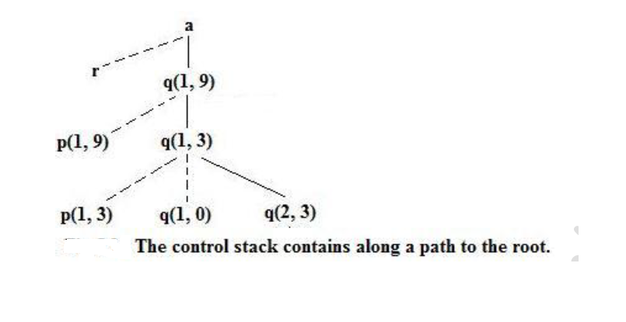

- The control stack contains the a, q(1, 9), q(1, 3), q(2, 3) nodes along the path to the root and no other nodes.

The scope of a Declaration
- A declaration in a language is a syntactic construct that associates information with a name.
- The scope rules of a language determine which declaration of a name applies when the name appears in the text of a program.
- The portion of the program to which a declaration applies is called the scope of that declaration.
- An occurrence of a name in a procedure is said to be local to the procedure if it is in the scope of a declaration within the procedure; otherwise, the occurrence is said to be nonlocal.

Bindings of Names
- Data object is called as storage location that can hold values.
- In programming language semantics, the term environment refers to a function that maps a storage location, and the term state refers to a function that maps a storage location to the value held there.

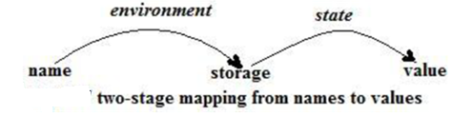

- Environments and states are different; an assignment changes the state, but not the environment.
- For example: suppose that storage address 100, associated with variable pi, holds 0. After the assignment pi := 3.14, the same storage address is associated with pi, but the value held there is 3.14.
- When an environment associates storage location s with a name x, say that x is bound to s; the association itself is referred to as a binding of x.
- In the term storage “location” if x is not of a basic type, the storage s for x may be collection of memory words.
- A binding is the dynamic counterpart of a declaration.
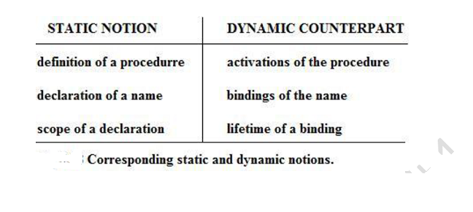
5.7 Storage Organization
Subdivision of Run-Time Memory
- Suppose that the compiler obtains a block of storage from the operating system for the compiled program to run in.
- This run-time storage might be subdivided to hold:
1. The generated target code,
2. Data objects, and
3. A counterpart of the control stack to keep track of procedure activations.
- The size of the generated target code is fixed at compile time, so the compiler can place it in a statically determined area, in the low end of memory.
- Similarly, the size of some of the data objects may also be known at compile time, these data also place in a statically determined area.
- This is because the addresses of these objects can be compiled into target code.
- Data objects whose lifetimes are contained in that of an activation can be allocated on the stack, along with the other information associated with the activation.
- A separate area of run-time memory, called a heap, holds all other information.

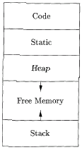

- The sizes of the stack and the heap can change as the program executes.
Activation Records
- Information needed by a single execution of a procedure is managed using a contiguous block of storage called an activation record or frame, consisting of collection of fields.

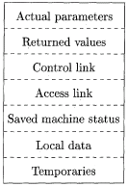

- For language like Pascal and C, it is customary to push the activation record of a procedure on the run-time stack when the procedure is called and to pop the activation record off the stack when control returns to the caller.
- The purpose of the fields of an activation record is as follows:
- Temporary values, such as those arising in the evaluation of expression are stored in the field for temporaries.
- The field for local data that is local to an execution of a procedure.
- The field for saved machine status holds the information about the state of the machine just before the procedure is called. This information includes the values of the program counter and machine register that have to be restored when control returns from the procedure.
- The optional access link is used to refer to nonlocal data held in other activation records.
- The optional control link points to the activation record of the caller.
- The field for actual parameters is used by the calling procedure to supply parameters to the called procedure.
- The field for the returned value is used by the called procedure to return a value to the calling procedure. Again, this value is returned in a register for greater efficiency.
- The size of each of these fields can be determined at the time a procedure is called.

Compile-time layout of local data
- The amount of storage needed for a name is determined from its type.
- The field for local data is laid out as the declarations in a procedure are examined at compile-time.
- The storage layout for data objects is strongly influenced by the addressing constraints of the target machine.

5.8 Storage Allocation Strategies
- A different storage-allocation strategy is used in each of the three data areas in the organisation of the following fig.
1. Static allocation lays out storage for all data objects at compile time.
2. Stack allocation manages the run-time storage as a stack.
3. Heap allocation allocates and deallocates storage as needed at run-time from a data area known as a heap.

Static allocation
- In static allocation, names are bound to storage as the program is compiled, so there is no need for a run-time support package.
- Since the bindings do not change at run-time, every time a procedure is activated, its names are bound to the same storage locations.
- This property allows the values of local names to be retained across activations of a procedure.
- i.e. when control returns to a procedure, the values of the locals are the same as they were when control left last time.
- From the type of a name, the compiler deter mines the amount of storage to set aside for that name.
- The address of this storage consists of an offset from an end of the activation record for the procedure.
- The compiler must eventually decide where the activation records go, relative to the target code and to one another.
- Once this decision is made, the position each activation record, and hence of the storage for each name in the record is fixed.
- At compile the addresses at which the target code can find the data it operates on is filled.
- Similarly, the addresses at which information is to be saved when a procedure call occurs are also known at compile time.
- Some limitations of using static allocation:
- The size of a data object and constraints on its position in memory must be known at compile time.
- Recursive procedures are restricted, because all activations of a procedure use the same bindings for local names.
- Data structures cannot be created dynamically, since there is no mechanism for storage allocation at run time.
- FORTRAN use static storage allocation.

Stack allocation
- Stack allocation is based on the idea of a control stack.
- The storage is organized as a stack, and activation records are pushed and popped as activation begins and end, respectively.
- Storage for the locals in each call of a procedure is contained in the activation record for that call.
- Thus the locals are bound to fresh storage in each activation, because a new activation record is pushed onto the stack when call is made.
- Further, the values of locals are deleted when the activation ends; i.e. the values are lost because the storage for locals disappears when the activation record is popped.
- Stack allocation – in which the sizes of all activation records are known at compile time.
- Suppose that register top marks the top of the stack.
- At run-time, an activation record can be allocated and deallocated by incrementing and decrementing top, respectively, by the size of the record.
- If the procedure q has an activation record of size a, then top is incremented by a just before the target code q is executed.
- When control returns from q, top is decremented by a.
- The procedure calls are implemented by generating what are known as calling sequences in the target code.
- A call sequence allocates an activation record and enters information into its fields.
- A return sequence restores the state of the machine so the calling procedure can continue execution.

The call sequence:
- The caller evaluates actual.
- The caller stores a return address and the old value of top_sp into the callee’s activation record. The caller then increments top_sp. top_sp is moved past the caller’s local data and temporaries and the callee’s parameter and status fields.
- The callee saves register values and other status information.
- The callee initializes its local data and begins execution.
The return sequence:
- The callee places a return value next to the activation record of the caller.
- Using the information in the status field, the callee restores top_sp and other registers and branches to a return address in the caller’s code.
- Although top_sp has been decremented, the caller can copy the returned value into its own activation record and use it to evaluate an expression.

Heap Allocation
- The stack allocation strategy cannot be used if either of the following is possible:
- The value of local names must be retained when activation ends.
- A called activation outlives the caller. (only if flow of control between procedures is not correctly depicted.)
- In each of the above cases, the deallocation of activation records need not occur in a last-in first-out fashion, so storage cannot be organised as a stack.
- Heap allocation bundle out pieces of contiguous storage.
- Pieces may be deallocated in any order, so over time the heap will consist of alternate areas that are free and in use.

5.9 Access to Non-local Names
- The storage-allocation strategies are used to permit access to nonlocal names.
- The scope rules of a language determine the treatment of reference to non-local names.
- The lexical- or static-scope rule determines the declaration that applies to a name by examining the program text alone. (example: Pascal, C, Ada)
- The dynamic-scope rule determines the declaration applicable to a name at run-time, by considering the current activations. (example: Lisp, APL, snobol)
Blocks
- A block is a statement containing its own local data declarations.
- In C, a block has the syntax
{ declarations statements }
- A characteristics of blocks is their nesting structure.
- Delimiters mark the beginning and end of a block.
- Delimiters ensure that one block is either independent of another, or is nested inside the other.
- i.e. it is not possible for two blocks B1 and B2 to overlap in such a way that first B1 begins, then B2, but B1 ends before B2.
- This nesting property is referred to as block structure.
- The scope of a declaration in a block-structured language is given by the most closely nested rule:
- The scope of a declaration in a block B includes B.
- If a name x is not declared in a block B, then an occurrence of x in B is in the scope of a declaration of x in an enclosing block B’ such that
i) B’ has a declaration of x, and
ii) B’ is more closely nested around B than any other block with a declaration of x.
- Each declaration initializes the declared name to the number of the block that it appears in.
- The scope of the declaration of b in B0 does not include B1, because b is redeclared in B1, indicated by B0 – B1 in the figure.
- Such gap is called a hole in the scope of the declaration. Block structure can be implemented using stack allocation.
- Since the scope of a declaration does not extend outside the block in which it appears, the space for the declared name can be allocated when the block is entered, and deallocated when control leaves the block.
- This view of blocks is called as parameterless procedure, called only from the point just before the block and returning only to the point just after the block.
Lexical scope without nested procedures
- The procedure definitions cannot be nested in C.
- If there is a nonlocal reference to a name a in some function, then a must be declared outside any function.
- The scope of a declaration outside a function consists of the function bodies that follow the declaration, with holes if the name is redeclared within a function.
- In the absence of nested procedures, the stack allocation strategy for local names can be used directly for a lexically scoped language like C.
- The benefit of static allocation for nonlocals is that declared procedures can freely be passed as parameters and returned as results.
Lexical scope with nested procedures
- A nonlocal occurrence of a name a in a Pascal procedure is in the scope of the most closely nested declaration of a in the static program text.
- The most closely nested declaration of a is on line 2 in the procedure consisting of the entire program.
- The most closely nested rule applies to procedure names as well.
- Procedure exchange, called by partition on line 17, is nonlocal to partition.
- Applying the rule, first check if exchange is defined within quicksort; since it is not, look it in the main program sort.
Nesting depth
- The nesting depth of a procedure is used to implement lexical scope.
- Let the name of the main program be at nesting depth 1; add 1 to the nesting depth as we go from an enclosing to an enclosed procedure.
- The procedure partition on line 13 is at nesting depth 3. (since the occurrence of a, v, i on line 15 -17 have nesting depth 1, 2 and 3 respectively.
Access links
- A direct implementation of lexical scope for nested procedures is obtained by adding a pointer called an access link to each activation record. If procedure p is nested immediately within q in the source text, then the access link in an activation record for p points to the access link in the record for the most recent activation of q.

Dynamic Scope
- Under dynamic scope. A new activation inherits the existing bindings of nonlocals names to storage.
- Approaches for implementing dynamic scope.
- Deep access. with access links and use the control link to search into stack, looking for the first activation record containing storage for the nonlocal name. The term deep access comes from the fact that the search may go deep into the stack. The depth to which the search may go depends on the input to the program and cannot be determined at compile time.
- Shallow access. The idea is to hold the current value of each name in statically allocated storage. When a new activation of a procedure p occurs, a local name n in p takes over the storage statically allocated for n. The previous value of n can be saved in the activation record for p and must be restored when the activation of p ends.
5.10 Parameter Passing
- When one procedure calls another, the usual method of communication between them is through nonlocal names and through parameters of the called procedure.
- Common methods for associating actual and formal parameters are: call-by value, call-by reference, copy-restore, call-by name, and macro expansion.

Call-by-value
- This is the simplest possible method of passing parameters.
- The actual parameters are evaluated and their r-values are passed to the called procedure.
- Call-by value can be implemented as follows:
- A formal parameter is treated just like a local name, so the storage for the formals is in the activation record of the called procedure.
- The caller evaluates the actual parameters and places their r-values in the storage for the formals.
- A distinguishing feature of call-by value is that operations on the formal parameters do not affect values in the activation record of the caller.
- Under call-by value, the effect of the call swap(a, b) is equivalent to the sequence of steps
x := a
y := b
temp := x
x := y
y := temp
where x, y and temp are local to swap( ).
- Although these assignments change the values of the locals x, y, temp, the changes are lost when control returns from the call and the activation record for swap is deallocated.
- The call therefore has no effect on the activation record of the caller.

Call-by reference (call-by address or call-by location)
- When parameters are passed by reference, the caller passes to the called procedure a pointer to the storage address of each actual parameter.
- If an actual parameter is a name or an expression having an l-value, then that l-value itself is passed.
- If the actual parameter is an expression, like a+b or 2, that has no l-value, then the expression is evaluated in a new location, and the address of that location is passed.
- A reference to a formal parameter in the called procedure becomes (in the target code) an indirect reference through the pointer passed to the called procedure.

Copy restore (copy-in copy-out or value-result)
- A hybrid between call-by value and call-by reference is copy restore linkage.
- Before control flows to the called procedure, the actual parameter are evaluated. The r-values of the actuals are passed to the called procedure as in cal-by value. In addition the l-values of those actual parameters having l-values are determined before the call.
- When control returns, the current r-values of the formal parameters are copied back into the l-values of the actuals, using the l-values computed before the call. Only actuals having l-values are copied.
- The first step “copies in” the values of the actuals into activation record of the called procedure into the storage of the formals.
- The second step “copies out” the final values of the formals into the activation record of the caller into l-values computed from the actuals before the call.

Call-by name
- Call-by name is defined by the copy-rule of Algol, which is:
- The procedure is treated as if it were a macro; i.e. its body is substituted for the call in the caller, with the actual parameters literally substituted for the formals. Such a literal substitution is known as macro expansion or in-line substitution.
- The local names of the called procedure are kept distinct from the names of the calling procedure.
- The actual parameters are surrounded by parenthesis if necessary to preserve their integrity.

